

**UNIVERSITY INSTITUTE OF COMPUTING**

**PROJECT REPORT ON :**

**GYM MEMBERSHIP MANAGEMENT SYSTEM**

**Program Name: BCA**

**Subject Name/Code:**

**DATABASE MANAGEMENT SYSTEM**

**(24CAP-204)**

**Submitted by:**

Name: SEKA ARMEL

UID: 24BCA10005

Section: 8

Group: A

**ABSTRACT**

The **Gym Membership Management System** is a database management project that keeps organised records of members, trainers, plans, and payments in order to automate and streamline gym operations. A relational database that guarantees data accuracy, integrity, and accessibility takes the place of manual record-keeping in this system. It facilitates essential features like tracking payments, assigning trainers, managing membership plans, and member registration. The system makes it possible to efficiently retrieve data and generate analytical reports, such as trainer workloads and revenue summaries, by utilising SQL queries and views. All things considered, this project shows how DBMS principles can be applied effectively to create a scalable and dependable gym membership management system.

## **Capture d'écran 2025-08-01 201547**Problem Identification

Domain: The Wellness and Fitness Sector  
Through organised exercise, nutrition, and wellness initiatives, the fitness and wellness sector seeks to enhance lifestyle, mental health, and physical health. By offering facilities, qualified trainers, and individualised membership plans to people looking to reach their fitness objectives, gyms and fitness centres play a critical role in this field.  
A huge amount of data is produced every day in contemporary gyms, including membership subscriptions, workout plans, member information, trainer details, and payment transactions. Efficient management of this data is necessary to guarantee seamless operations and a positive client experience.

### Existing Problems: - Manual data entry causes inconsistency and loss of records. - Difficulty in tracking membership expiry and renewal dates. - No centralized view of trainers, plans, and payments. - Lack of automated reports for revenue or member status.

1. **Describe the Scope**

The goal of the Gym Membership Management System is to create a centralised relational database that efficiently oversees all crucial gym membership operations. The system makes sure that all payment, trainer, and member data is effectively linked, stored, and retrieved.

In-Scope (What the System Covers):

1. **Member Registration and Personal Data:**

* Store essential details such as name, age, gender, contact number, and join date.
* Allow tracking of each member’s active status through membership records.

1. **Trainer Assignments and Specializations:**

* Record trainer information, including name, contact details, and area of expertise.
* Link trainers to members through the membership table for personalized guidance.

1. **Membership Plans (Duration and Cost):**

* Define various subscription plans based on duration (e.g., 1, 3, or 6 months) and price.
* Ensure each member is assigned to one valid plan at a time.



1. **Payments, Renewals, and Expiration Tracking:**

* Maintain a detailed record of payments, including amount, date, and method.
* Automatically calculate membership expiry based on the plan duration.
* Enable easy retrieval of pending or expired memberships for follow-up.

### Stakeholder Analysis

|  |  |  |
| --- | --- | --- |
| Stakeholder | Role | Needs |
| Gym Owner | Administrator | Needs revenue reports, trainer workload stats |
| Trainers | Staff | View assigned members and their plan duration |
| Members | Clients | Manage memberships and payment status |
| Receptionist | Operator | Register new members, record payments |

1. **Identify Problems**

- No automated tracking for expired memberships.  
- Manual payment records lead to errors.  
- No integrated view to link members, trainers, and plans.  
- Limited insights into revenue and member statistics.

### Evaluate Current Solutions

Some small gyms use Excel or mobile apps, but they fail to:  
- Handle large datasets efficiently.  
- Maintain relationships between entities (members, trainers, payments).  
- Generate advanced reports dynamically.



### Prioritize Requirements

|  |  |  |
| --- | --- | --- |
| Priority | Requirement | Description |
| High | Centralized database | Store all membership-related data |
| High | Payment tracking | Automate payment and revenue logs |
| Medium | Trainer assignment | Link members with trainers |
| Medium | Reports | Generate insights on revenue and memberships |

## Conceptual Design Goals

Objective: Develop a relational database that integrates member, trainer, plan, membership, and payment data, supports complex queries, and ensures data integrity.  
**Goals:**  
- Create normalized tables to minimize redundancy.  
- Implement 1-to-Many relationships.  
- Enable analytical queries for decision-making.  
- Support SQL views for simplified reporting.

## **Conceptual Design**

Entities and Attributes :

* Members:
* Member_ID (PK)
* Name
* Age
* Gender
* Phone
* Join_Date



* Trainers:
* Trainer_ID (PK)
* Name
* Specialty
* Phone
* Plans:
* Plan_ID (PK)
* Name
* Duration (months)
* Price
* Memberships:
* Membership_ID (PK)
* Member_ID (FK)
* Trainer_ID (FK)
* Plan_ID (FK)
* Start_Date
* End_Date
* Payments:
* Payment_ID (PK)
* Membership_ID (FK)
* Amount
* Payment_Date
* Method

**Relational Schema:**  
Members ⇄ Memberships (1-to-Many, via Member_ID)  
Trainers ⇄ Memberships (1-to-Many, via Trainer_ID)  
Plans ⇄ Memberships (1-to-Many, via Plan_ID)  
Memberships ⇄ Payments (1-to-Many, via Membership_ID)

* 

### ****Implementation Progress****

The **implementation phase** involves translating the conceptual design into actual database structures and verifying that relationships, constraints, and queries function as intended. This phase includes **table creation**, **data insertion**, and **execution of SQL queries** to demonstrate data integrity and retrieval efficiency.

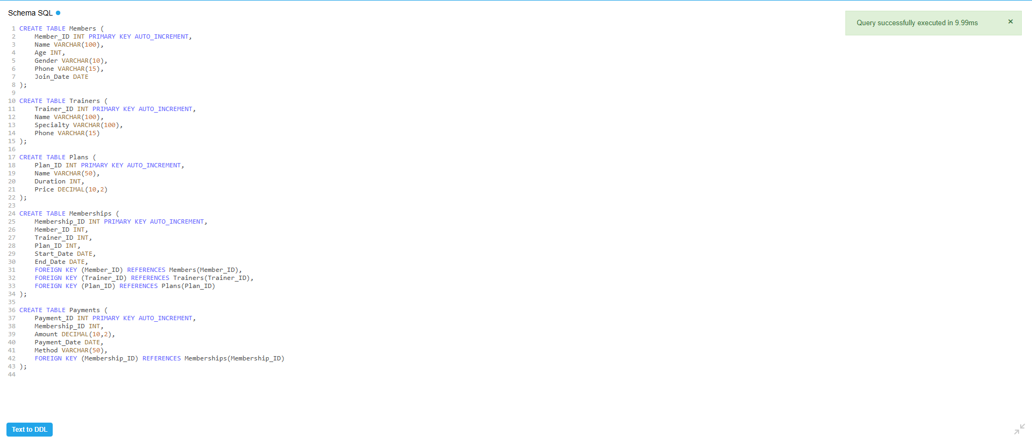

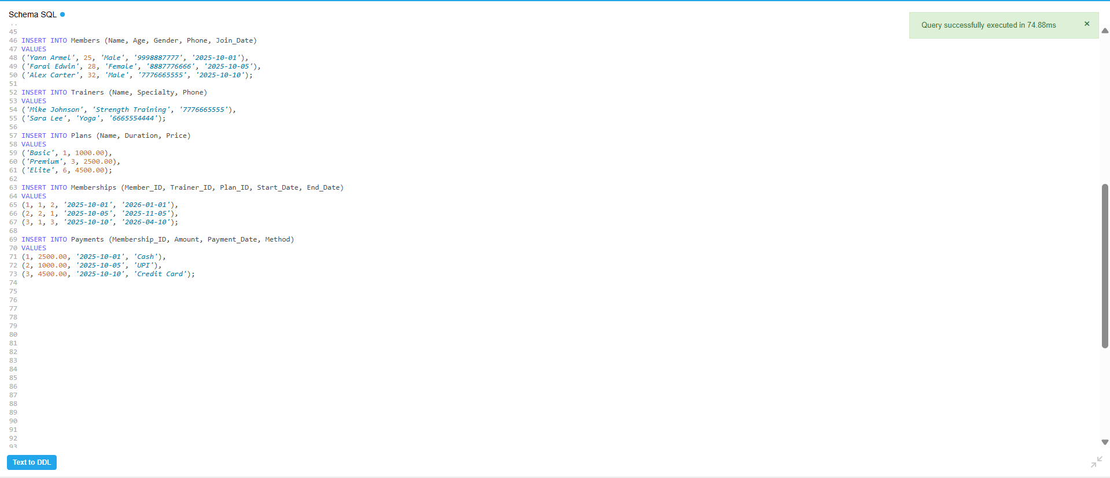

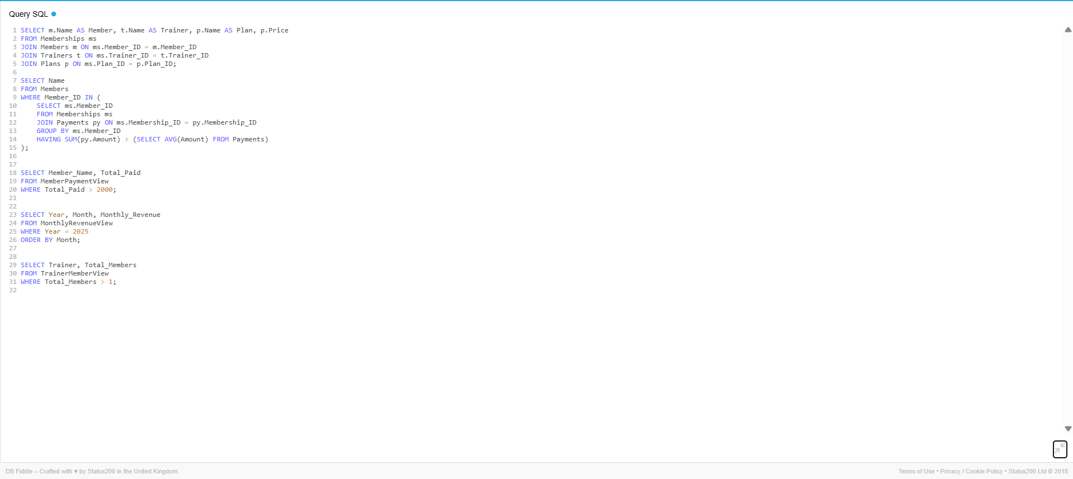



## **Capture d'écran 2025-08-01 201547**SQL Views Implementation

Views created to simplify data analysis and reporting, including MemberPaymentView, TrainerMemberView, and MonthlyRevenueView.

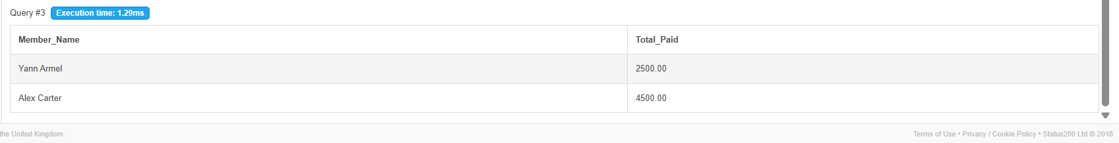



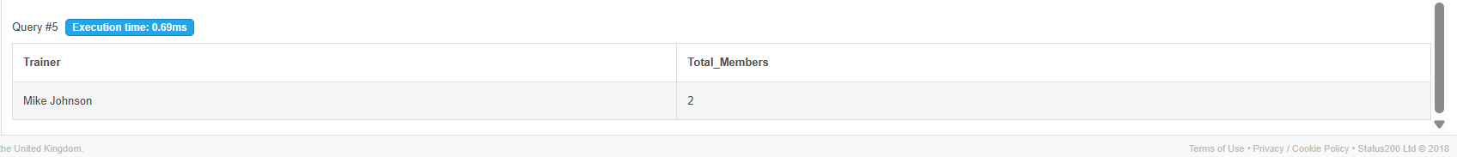

## Challenges and Solutions

|  |  |  |
| --- | --- | --- |
| Challenge | Description | Solution |
| Query Optimization | JOIN and subqueries slowed down with more data | Added indexes on foreign keys |
| Data Integrity | Inserting memberships without valid members/trainers caused errors | Enforced foreign key constraints |
| Scalability | Performance dropped on large datasets | Normalized data and optimized schema |

## **Capture d'écran 2025-08-01 201547**Results

The **Gym Membership Management System** was successfully implemented according to the project objectives. The following outcomes were achieved:

* Database Structure:

All tables — Members, Trainers, Plans, Memberships, and Payments — were created and properly normalized to ensure data integrity and eliminate redundancy. Each table is linked through well-defined primary and foreign keys.

* Relationships Established:

The relationships between entities were enforced using constraints:

Members ⇄ Memberships (1-to-Many, via Member_ID)  
Trainers ⇄ Memberships (1-to-Many, via Trainer_ID)  
Plans ⇄ Memberships (1-to-Many, via Plan_ID)  
Memberships ⇄ Payments (1-to-Many, via Membership_ID)

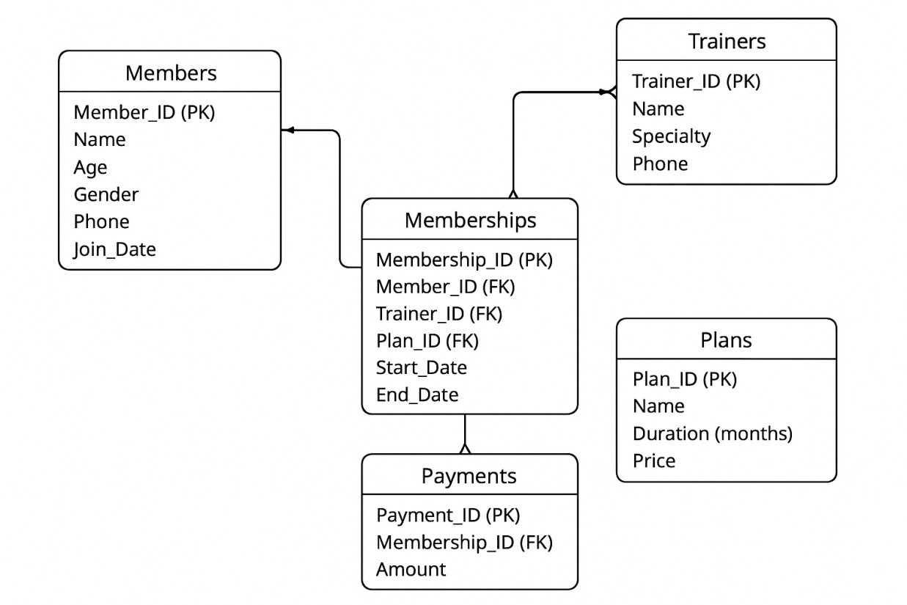



* Data Insertion:

Sample data was inserted into all major tables for testing. The records demonstrate realistic scenarios such as multiple members under one trainer, varied plan durations, and multiple payments for different memberships.

* ·Query Execution:

Complex SQL queries were executed successfully, including:

* Retrieving members with active memberships.
* Listing all payments made in a specific month.
* Calculating total revenue from memberships.
* Finding the most subscribed plan.
* Displaying trainer workloads (number of members assigned per trainer).
* System Performance:

Queries executed efficiently due to the normalized schema and proper indexing on key columns. Data retrieval and updates are smooth and reliable.

* Functional Validation:

The final system fulfills all defined goals:

* Centralized member management
* Organized trainer allocation
* Transparent payment tracking
* Simplified report generation



### ****Conclusion****

The **Gym Membership Management System** successfully demonstrates how the core principles of **Database Management Systems (DBMS)** can be applied to automate and optimize gym operations.  
By integrating members, trainers, membership plans, and payment information into a **centralized relational model**, the system ensures that data is accurate, consistent, and easily accessible.

Through the normalization of data and the use of relational constraints, the system minimizes redundancy while maintaining data integrity. This structure supports essential business functions such as tracking memberships, managing trainer assignments, and monitoring payment histories.

Additionally, the use of **SQL queries and database views** enables efficient data retrieval, reporting, and analysis — making the management of memberships and financial performance straightforward and transparent.

In conclusion, the project achieves all its objectives by providing a **scalable, maintainable, and efficient** database solution. It lays a strong foundation for future enhancements such as integrating attendance tracking, workout management, or automated notifications for renewals, further improving the digital transformation of gym management.